Software Requirements Specification
for
DLP Tool
Version 1.0 approved
Prepared by

2024/12/01
Table of Contents
1. Introduction 1
1.1 Purpose 1
1.2 Document Conventions 1
1.3 Intended Audience and Reading Suggestions 1
1.4 Project Scope 2
1.5 References 2
2. Overall Description 2
2.1 Product Perspective 2
2.2 Product Features 3
2.3 User Classes and Characteristics 3
2.4 Operating Environment 4
2.5 Design and Implementation Constraints 4
2.6 User Documentation 4
2.7 Assumptions and Dependencies 5
3. System Features 5
3.1 Homomorphic Encryption for Secure Data Processing 3.1.1 Description and Priority 5
3.2 Attention-Seeking Mode with Score System 3.2.1 Description and Priority 6
3.3 Phishing URL Detection and Blocking 6
3.4 Steganographic Detection Module 7
4. External Interface Requirements 8
4.1 User Interfaces 8
5. Other Nonfunctional Requirements 10

Revision History
Name | Date | Reason For Changes | Version

Introduction

Purpose
This document specifies the software requirements for the Data Loss Prevention (DLP) tool proposed under the research project titled “Leveraging Machine Learning for Data Loss Prevention”. This SRS covers the design, implementation, and integration of four primary components of the DLP tool:
- Homomorphic Encryption for Data Processing.
- Attention-Seeking Mode with a Score System Using Machine Learning.
- Phishing URL Detection and Blocking System with Screenshot Capture.
- Steganographic Detection Module.
The scope of this SRS encompasses the detailed functionality and performance specifications for the above components, focusing on enhancing data security, preventing data breaches, and addressing modern cybersecurity challenges.

Document Conventions
This document follows the following conventions:
- Bold font: Titles and critical terms.
- Italic font: References and external documents.
- [#]: Citation from references listed in section 1.5.
- Prioritization of requirements is inherited hierarchically, with high-level objectives cascading to detailed functional and non-functional requirements.

Intended Audience and Reading Suggestions
The document is intended for the following stakeholders:
- Developers: For understanding the technical requirements and system architecture.
- Project Managers: For tracking the development process and resource allocation.
- Security Teams: For reviewing DLP integration points and assessing cybersecurity enhancements.
- Testers: For identifying key functional and performance metrics for testing.
- Documentation Writers: For creating user manuals and operational guidelines.
Suggested reading order:
- Overview (Sections 1 and 2).
- Functional Requirements (Section 3).
- Specific component designs (Sections 4 and 5).

Project Scope
The proposed DLP tool aims to mitigate risks related to modern cybersecurity threats and improve data protection capabilities. Its primary features include:
- Ensuring secure data processing using homomorphic encryption, preserving confidentiality without decryption.
- Enhancing incident response by prioritizing security alerts using machine learning-based scoring mechanisms.
- Blocking phishing URLs and mitigating webcam brute force attacks through dynamic and static URL analysis.
- Detecting hidden data breaches with a steganographic detection module leveraging advanced forensic techniques.
The ultimate goal is to deliver a comprehensive, adaptive DLP solution that aligns with corporate cybersecurity strategies, reduces alert fatigue, and fortifies organizational data against sophisticated attacks.

References
- R. C., Harshini P. S., N. T., R. C. T., & Srinivas D. B., “A Multi-Stage Partial Homomorphic Encryption Scheme for Secure Data Processing in Cloud Computing,” 2023.
- Grushka-Cohen et al., “Simulating User Activity for Assessing the Effect of Sampling on DB Activity Monitoring,” Springer, 2020.
- Gautam, T., & Jain, A., “Analysis of brute force attack using TG-Dataset,” IntelliSys, 2015.
- Kumar et al., “Steganography: Unveiling techniques and research agenda,” IntechOpen eBooks, 2024.

Overall Description

Product Perspective
The Data Loss Prevention (DLP) tool proposed in this project is a new, self-contained product designed to address modern cybersecurity challenges. It is not a follow-on product or replacement but an advanced system incorporating novel features to tackle issues inadequately addressed by existing tools.
The tool will operate as part of a comprehensive cybersecurity framework, integrating seamlessly with other enterprise security systems. Interfaces will include:
- Secure communication with cloud-based storage and third-party applications using encryption protocols.
- Machine learning models trained with historical incident data.
- URL analysis and blocking mechanisms integrated with browser security tools.
- Forensic detection algorithms for analyzing digital files and images.

Product Features
The DLP tool comprises four primary components:
- Homomorphic Encryption Module: Ensures secure data processing by allowing operations on encrypted data without decryption.
- Attention-Seeking Mode with Score System: Implements machine learning to prioritize alerts based on risk scores, reducing alert fatigue and improving incident response efficiency.
- Phishing URL Detection and Blocking System: Combines static and dynamic analysis techniques to detect and block malicious URLs. Includes screenshot capture for forensic analysis.
- Steganographic Detection Module: Detects hidden data within files and images using advanced algorithms to prevent data exfiltration.

User Classes and Characteristics
The primary user classes for the DLP tool are:
- Security Analysts:
  - Frequency of Use: High.
  - Expertise: Advanced technical knowledge of cybersecurity practices.
  - Role: Monitor alerts, investigate incidents, and respond to threats.
- System Administrators:
  - Frequency of Use: Moderate.
  - Expertise: Familiarity with infrastructure and integration processes.
  - Role: Deploy and manage the DLP tool, ensure compatibility with existing systems.
- Business Users:
  - Frequency of Use: Low.
  - Expertise: Limited technical knowledge.
  - Role: Understand alerts and follow remediation guidance when necessary.

Operating Environment
- Hardware: Servers with at least 16GB RAM, 500GB SSD, GPU Supports CUDA cores and modern CPUs supporting virtualization.
- Operating Systems: Linux (Ubuntu 20.04 LTS or higher), Windows Server 2019.
- Software Dependencies:
- Machine learning frameworks like TensorFlow or scikit-learn.
- Cryptographic libraries supporting homomorphic encryption.
- Browser plugins for URL analysis and blocking.

Design and Implementation Constraints
- Regulatory Compliance: Must comply with GDPR, HIPAA, and other data protection regulations.
- Hardware Limitations: Optimal performance requires high processing power for encryption and real-time URL analysis.
- Security Considerations:
- Encrypted data processing must ensure zero leakage.
- Network communications should use secure protocols (e.g., TLS 1.3).
- Integration Constraints: Compatibility with SIEM systems and other cybersecurity tools is critical.

User Documentation
The following documentation will be delivered:
- User Manual: Detailed guide on tool functionalities, installation, and troubleshooting.
- Online Help: Context-sensitive help integrated into the tool.
- Video Tutorials: Walkthroughs for configuring and using each component.
- Release Notes: Updates and changes for each version.

Assumptions and Dependencies
- The availability of labeled datasets for training machine learning models.
- Adequate computational resources for deploying homomorphic encryption and machine learning modules.
- Continued support for third-party libraries used in encryption and URL analysis.
- Dependency on browser compatibility for URL blocking plugins.

System Features

Homomorphic Encryption for Secure Data Processing
3.1.1 Description and Priority
Description: This feature ensures that sensitive data is processed securely using homomorphic encryption, allowing computations on encrypted data without requiring decryption. This protects data confidentiality throughout the data lifecycle.
Priority: High
- Benefit: 9 – Critical for secure data handling in cloud and third-party environments.
- Penalty: 8 – Risk of data breaches without this feature.
- Cost: 7 – High computational resources required for implementation.
- Risk: 6 – Complexity in encryption algorithm integration.

3.1.2 Stimulus/Response Sequences
- Stimulus: A data packet is classified as sensitive and flagged for processing.
Response: The system encrypts the data using homomorphic encryption before initiating any processing.
- Stimulus: An application requests computation on the encrypted dataset.
Response: The system performs the computation without decrypting the data and provides encrypted results.

3.1.3 Functional Requirements
- REQ-1: The system must support partial and fully homomorphic encryption schemes for different data processing needs.
- REQ-2: Encrypted data must maintain the integrity of computation results, ensuring output consistency.
- REQ-3: The system should ensure encryption and decryption keys are securely stored and accessed only by authorized users.
- REQ-4: The tool must handle invalid encryption or computation requests by logging the event and notifying administrators.

Attention-Seeking Mode with Score System
3.2.1 Description and Priority
Description: This feature uses machine learning to prioritize alerts by assigning a risk score, reducing alert fatigue and improving incident response times.
Priority: High
- Benefit: 9 – Enables efficient threat prioritization.
- Penalty: 7 – Increased risk of overlooked critical incidents without this feature.
- Cost: 6 – Moderate cost associated with developing machine learning models.
- Risk: 5 – Potential misclassification of alerts during initial training.

3.2.2 Stimulus/Response Sequences
- Stimulus: A new security alert is generated.
Response: The system evaluates the alert using historical data and assigns a risk score.
- Stimulus: A high-risk score alert is detected.
Response: The system sends an immediate notification to the security team for action.
- 3.2.3 Functional Requirements
- REQ-1: The system must utilize supervised learning models trained on historical security incident data.
- REQ-2: Risk scores should be recalibrated in real-time based on new data inputs.
- REQ-3: High-priority alerts must trigger automated notifications with detailed context.
- REQ-4: Low-priority alerts should be grouped and summarized to reduce noise.

Phishing URL Detection and Blocking

3.3.1 Description and Priority
Description: This feature detects and blocks phishing URLs using static and dynamic analysis, preventing access to malicious websites.
Priority: High
- Benefit: 8 – Protects against phishing attacks effectively.
- Penalty: 8 – High risk of data exfiltration without this feature.
- Cost: 5 – Moderate cost due to required integration with browser security.
- Risk: 6 – High dependency on accurate URL analysis to avoid false positives.

3.3.2 Stimulus/Response Sequences
- Stimulus: A user attempts to access a URL.
Response: The system analyzes the URL and blocks access if deemed malicious.
- Stimulus: A blocked URL triggers an investigation request.
Response: The system logs the event and captures a screenshot of the associated webpage for review.

3.3.3 Functional Requirements
- REQ-1: The system must analyze URLs using both static characteristics (e.g., structure, domain) and dynamic behaviors (e.g., script execution).
- REQ-2: Screenshots of blocked URLs must be stored securely for forensic analysis.
- REQ-3: Users must be notified of blocked URLs with an explanation and suggestions for safe browsing.
- REQ-4: Administrators should be able to override URL blocking when necessary.

Steganographic Detection Module

3.4.1 Description and Priority
Description: Detects hidden data within files and images using advanced steganographic analysis techniques to prevent covert data exfiltration.
Priority: Medium
- Benefit: 7 – Enhances the detection of sophisticated data breaches.
- Penalty: 6 – Potential vulnerability if not implemented.
- Cost: 6 – Computationally intensive but feasible with optimization.
- Risk: 5 – May require frequent updates to detect evolving steganographic methods.

3.4.2 Stimulus/Response Sequences
- Stimulus: A file is uploaded to a monitored system.
Response: The system scans the file for steganographic patterns and flags suspicious content.
- Stimulus: Suspicious content is identified.
Response: The system generates an alert and quarantines the file for review.

3.4.3 Functional Requirements
- REQ-1: The system must detect common steganographic methods in images and text files.
- REQ-2: Flagged files must be isolated and encrypted to prevent unauthorized access.
- REQ-3: Alerts must provide detailed information on detected steganographic techniques.
- REQ-4: The system should allow periodic updates to detection algorithms.

External Interface Requirements

User Interfaces
The DLP tool will include the following user interface features:
- Dashboard: A centralized interface displaying security alerts, risk scores, and system activity logs.
- Screens:
  - Alert Management Screen: Displays prioritized security alerts with risk scores, allowing users to filter, acknowledge, or escalate incidents.
  - Data Processing Configuration Screen: Allows users to configure homomorphic encryption settings, including key management and data classification.
  - Phishing URL Review Screen: Shows blocked URLs with captured screenshots for further analysis.
  - Steganographic Analysis Screen: Provides a list of flagged files with detailed information about detected steganographic patterns.
- Standard Components:
  - Navigation Bar: Access to key modules.
  - Search Functionality: Enables users to query logs, alerts, or files.
  - Help Button: Links to documentation and troubleshooting guides.
  - Error Messages: Displayed in a consistent format, detailing the issue and providing suggested resolutions.
- Styling and Standards: Adherence to modern GUI standards (e.g., Material Design principles), ensuring usability and accessibility (e.g., WCAG compliance).

4.2 Hardware Interfaces
- Data Processing Hardware:
  - The system will interface with servers supporting AES-NI (Advanced Encryption Standard New Instructions) for efficient encryption computations.
  - Compatible with webcam devices for phishing attack monitoring and capturing screenshots during URL blocking events.
- Sensors and Measurement Tools: Support for high-resolution power sensors if used for advanced encryption analysis.
- Storage Devices:
  - Interfaces with SSDs for storing encrypted data, logs, and detection records.
  - Ensures secure data wiping protocols on removable storage devices.

4.3 Software Interfaces
- Operating Systems:
  - Linux distributions (e.g., Ubuntu 20.04+).
  - Windows Server 2019+ for enterprise deployments.
- Third-party Libraries and Tools:
  - Cryptographic Libraries: Open-source tools like Microsoft SEAL or Palisade for implementing homomorphic encryption.
  - Machine Learning Frameworks: TensorFlow or scikit-learn for risk scoring algorithms.
- Databases:
  - Relational databases like MySQL for storing system configuration, logs, and alert data.
  - NoSQL databases like MongoDB for fast retrieval of unstructured data (e.g., flagged files).
- Integrated Systems:
  - Compatibility with Security Information and Event Management (SIEM) platforms for real-time alert aggregation and correlation.
  - Integration with existing firewall or browser security plugins for URL analysis.

4.4 Communications Interfaces
- Protocols:
  - HTTP/HTTPS: For web-based user interfaces and remote monitoring.
  - SMTP: To send email notifications for high-risk alerts.
  - FTP/SFTP: For secure file transfer of logs or flagged files.
  - TLS 1.3: Ensures encrypted communication between system components.
- Message Formatting:
  - Alerts and logs formatted in JSON for compatibility with external systems.
  - Email notifications include plain-text summaries with optional attachments for detailed reports.
- Security Considerations:
  - All communication channels must implement end-to-end encryption.
  - Multi-factor authentication (MFA) for remote administrative access.
- Data Transfer Rates: The system should support high-speed data transmission, with minimum rates of 100 Mbps for real-time operations.
- Synchronization: Timestamp synchronization across all system components using NTP (Network Time Protocol) to ensure consistent logging and analysis.

Other Nonfunctional Requirements

5.1 Performance Requirements
- The system must process and prioritize 95% of security alerts within 500 milliseconds to ensure real-time responsiveness.
- Homomorphic encryption operations should execute with an overhead not exceeding 20% of baseline computational costs to maintain system efficiency.
- The phishing URL detection module must analyze and block URLs within 2 seconds to prevent user access to malicious sites.
- The steganographic detection module must process and flag a file of size up to 10MB in under 10 seconds for real-time usage scenarios.
- The DLP tool must handle a concurrent workload of at least 100,000 active alerts and 1,000 simultaneous users without performance degradation.

5.2 Safety Requirements
- The system must ensure that all quarantined files flagged by the steganographic detection module are read-only to prevent unintentional modification or execution.
- User access to flagged malicious URLs should be completely blocked, with no bypass options unless explicitly overridden by an administrator.
- Logs and incident reports must include timestamps and immutable records to maintain traceability in case of an investigation.
- The system must comply with ISO 27001 standards to ensure safe handling and storage of sensitive information.
- Automatic backups must be performed daily to prevent data loss in case of a system crash or failure.

5.3 Security Requirements
- All sensitive data must be encrypted using AES-256 during transmission and storage.
- User authentication must require multi-factor authentication (MFA) for accessing administrative features.
- Access to encryption keys must be limited to authorized personnel and stored securely using hardware security modules (HSMs).
- The system must detect and report unauthorized access attempts within 1 second to enable rapid response.
- Compliance with regulatory standards such as GDPR, HIPAA, and CCPA for data privacy and protection.
- The system should log all user actions for auditing and forensic purposes, ensuring logs are tamper-proof.

5.4 Software Quality Attributes
- Adaptability:
  - The tool must support integration with a variety of third-party security tools (e.g., SIEM systems, firewalls) with minimal configuration changes.
- Availability:
  - Ensure 99.9% uptime, with automatic failover mechanisms in case of server failure.
- Correctness:
  - The system should achieve 98% accuracy in prioritizing high-risk security alerts and detecting phishing URLs.
- Flexibility:
  - Modular architecture allowing future enhancements, such as adding new detection algorithms or support for additional encryption methods.
- Interoperability:
  - Must communicate effectively with enterprise IT infrastructures across Linux and Windows environments.
- Maintainability:
  - Clear and modular code structure, ensuring that updates can be deployed within two weeks of identifying issues or new requirements.
- Portability:
  - The system must be deployable on on-premises servers and cloud platforms, including AWS and Azure.
- Reliability:
  - The system should have less than 1% false positives in phishing URL detection and steganographic analysis.
- Reusability:
  - Core modules (e.g., encryption and machine learning components) should be reusable for other cybersecurity solutions.
- Robustness:
  - The system must handle up to 20% more traffic than anticipated peak loads without crashing.
- Testability:
  - Functional and non-functional tests should achieve 95% code coverage and include automated testing for key modules.
- Usability:
  - User interface designs must comply with WCAG 2.1 Level AA for accessibility and offer clear, actionable guidance to users.

Appendix A: Glossary
- Appendix A: Glossary
- AES (Advanced Encryption Standard): A symmetric encryption algorithm used to secure sensitive data.
- Alert Fatigue: A state where security teams are overwhelmed by the sheer number of alerts, potentially causing critical incidents to be overlooked.
- CCPA (California Consumer Privacy Act): A law that provides California residents with privacy rights and consumer protection.
- DLP (Data Loss Prevention): A set of tools and strategies to prevent the unauthorized transmission of data outside an organization.
- GDPR (General Data Protection Regulation): A regulation in the EU that focuses on data protection and privacy.
- HSM (Hardware Security Module): A physical device that manages and protects cryptographic keys.
- Homomorphic Encryption: A form of encryption that allows computations to be performed on encrypted data without decrypting it.
- MFA (Multi-Factor Authentication): A security system requiring multiple forms of verification to access a resource.
- Phishing: A cyberattack technique where attackers attempt to trick individuals into revealing sensitive information via fake websites or communications.
- SIEM (Security Information and Event Management): A platform for aggregating and analyzing security data from multiple sources.
- Steganography: The practice of concealing information within other non-secret data, such as images or audio files.

Appendix B: Analysis Models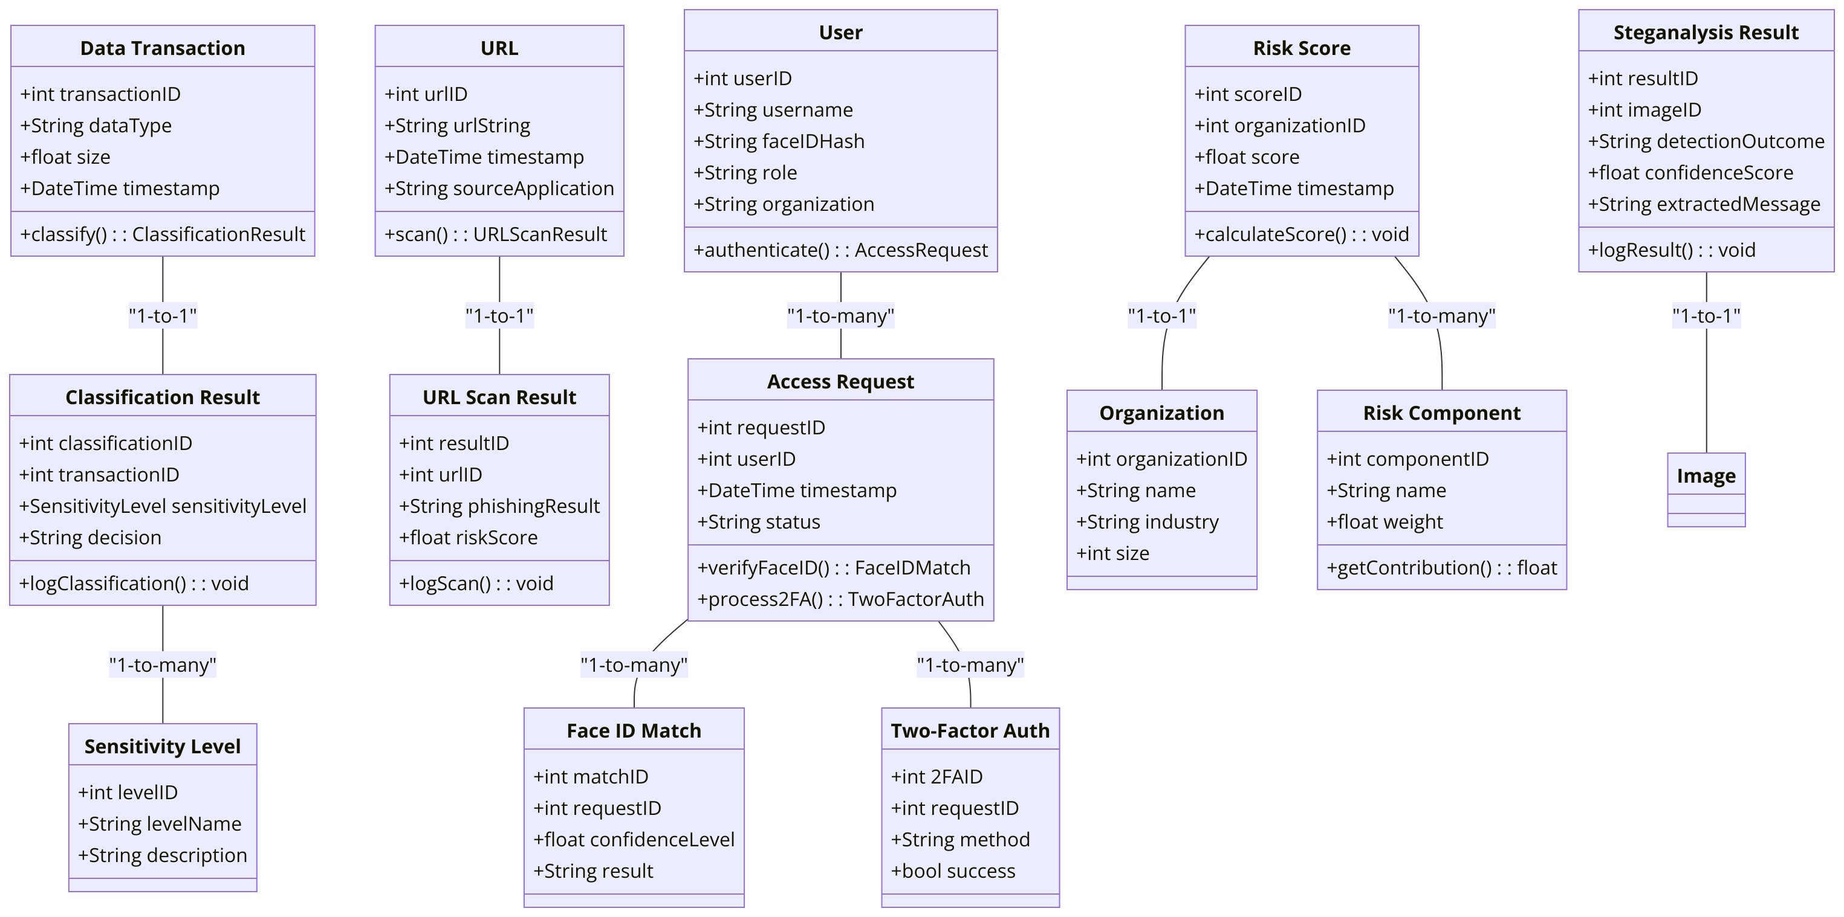
Figure 1: Class Digram
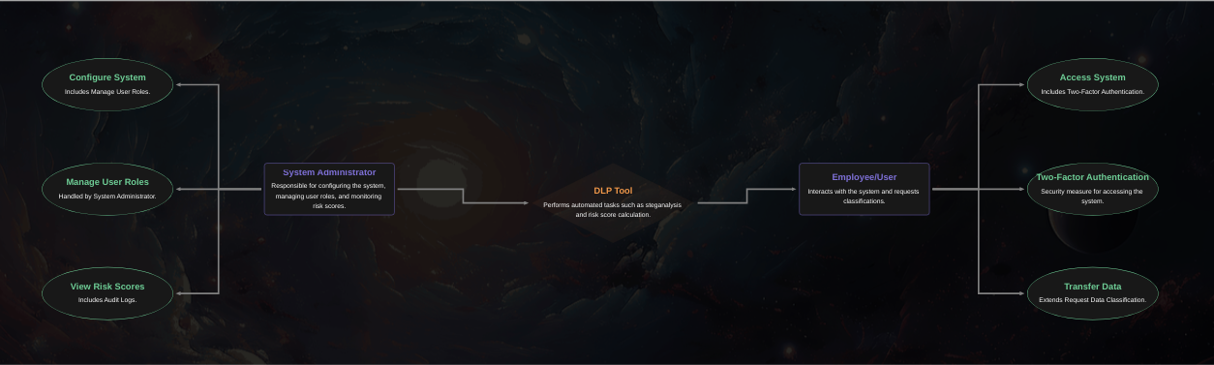
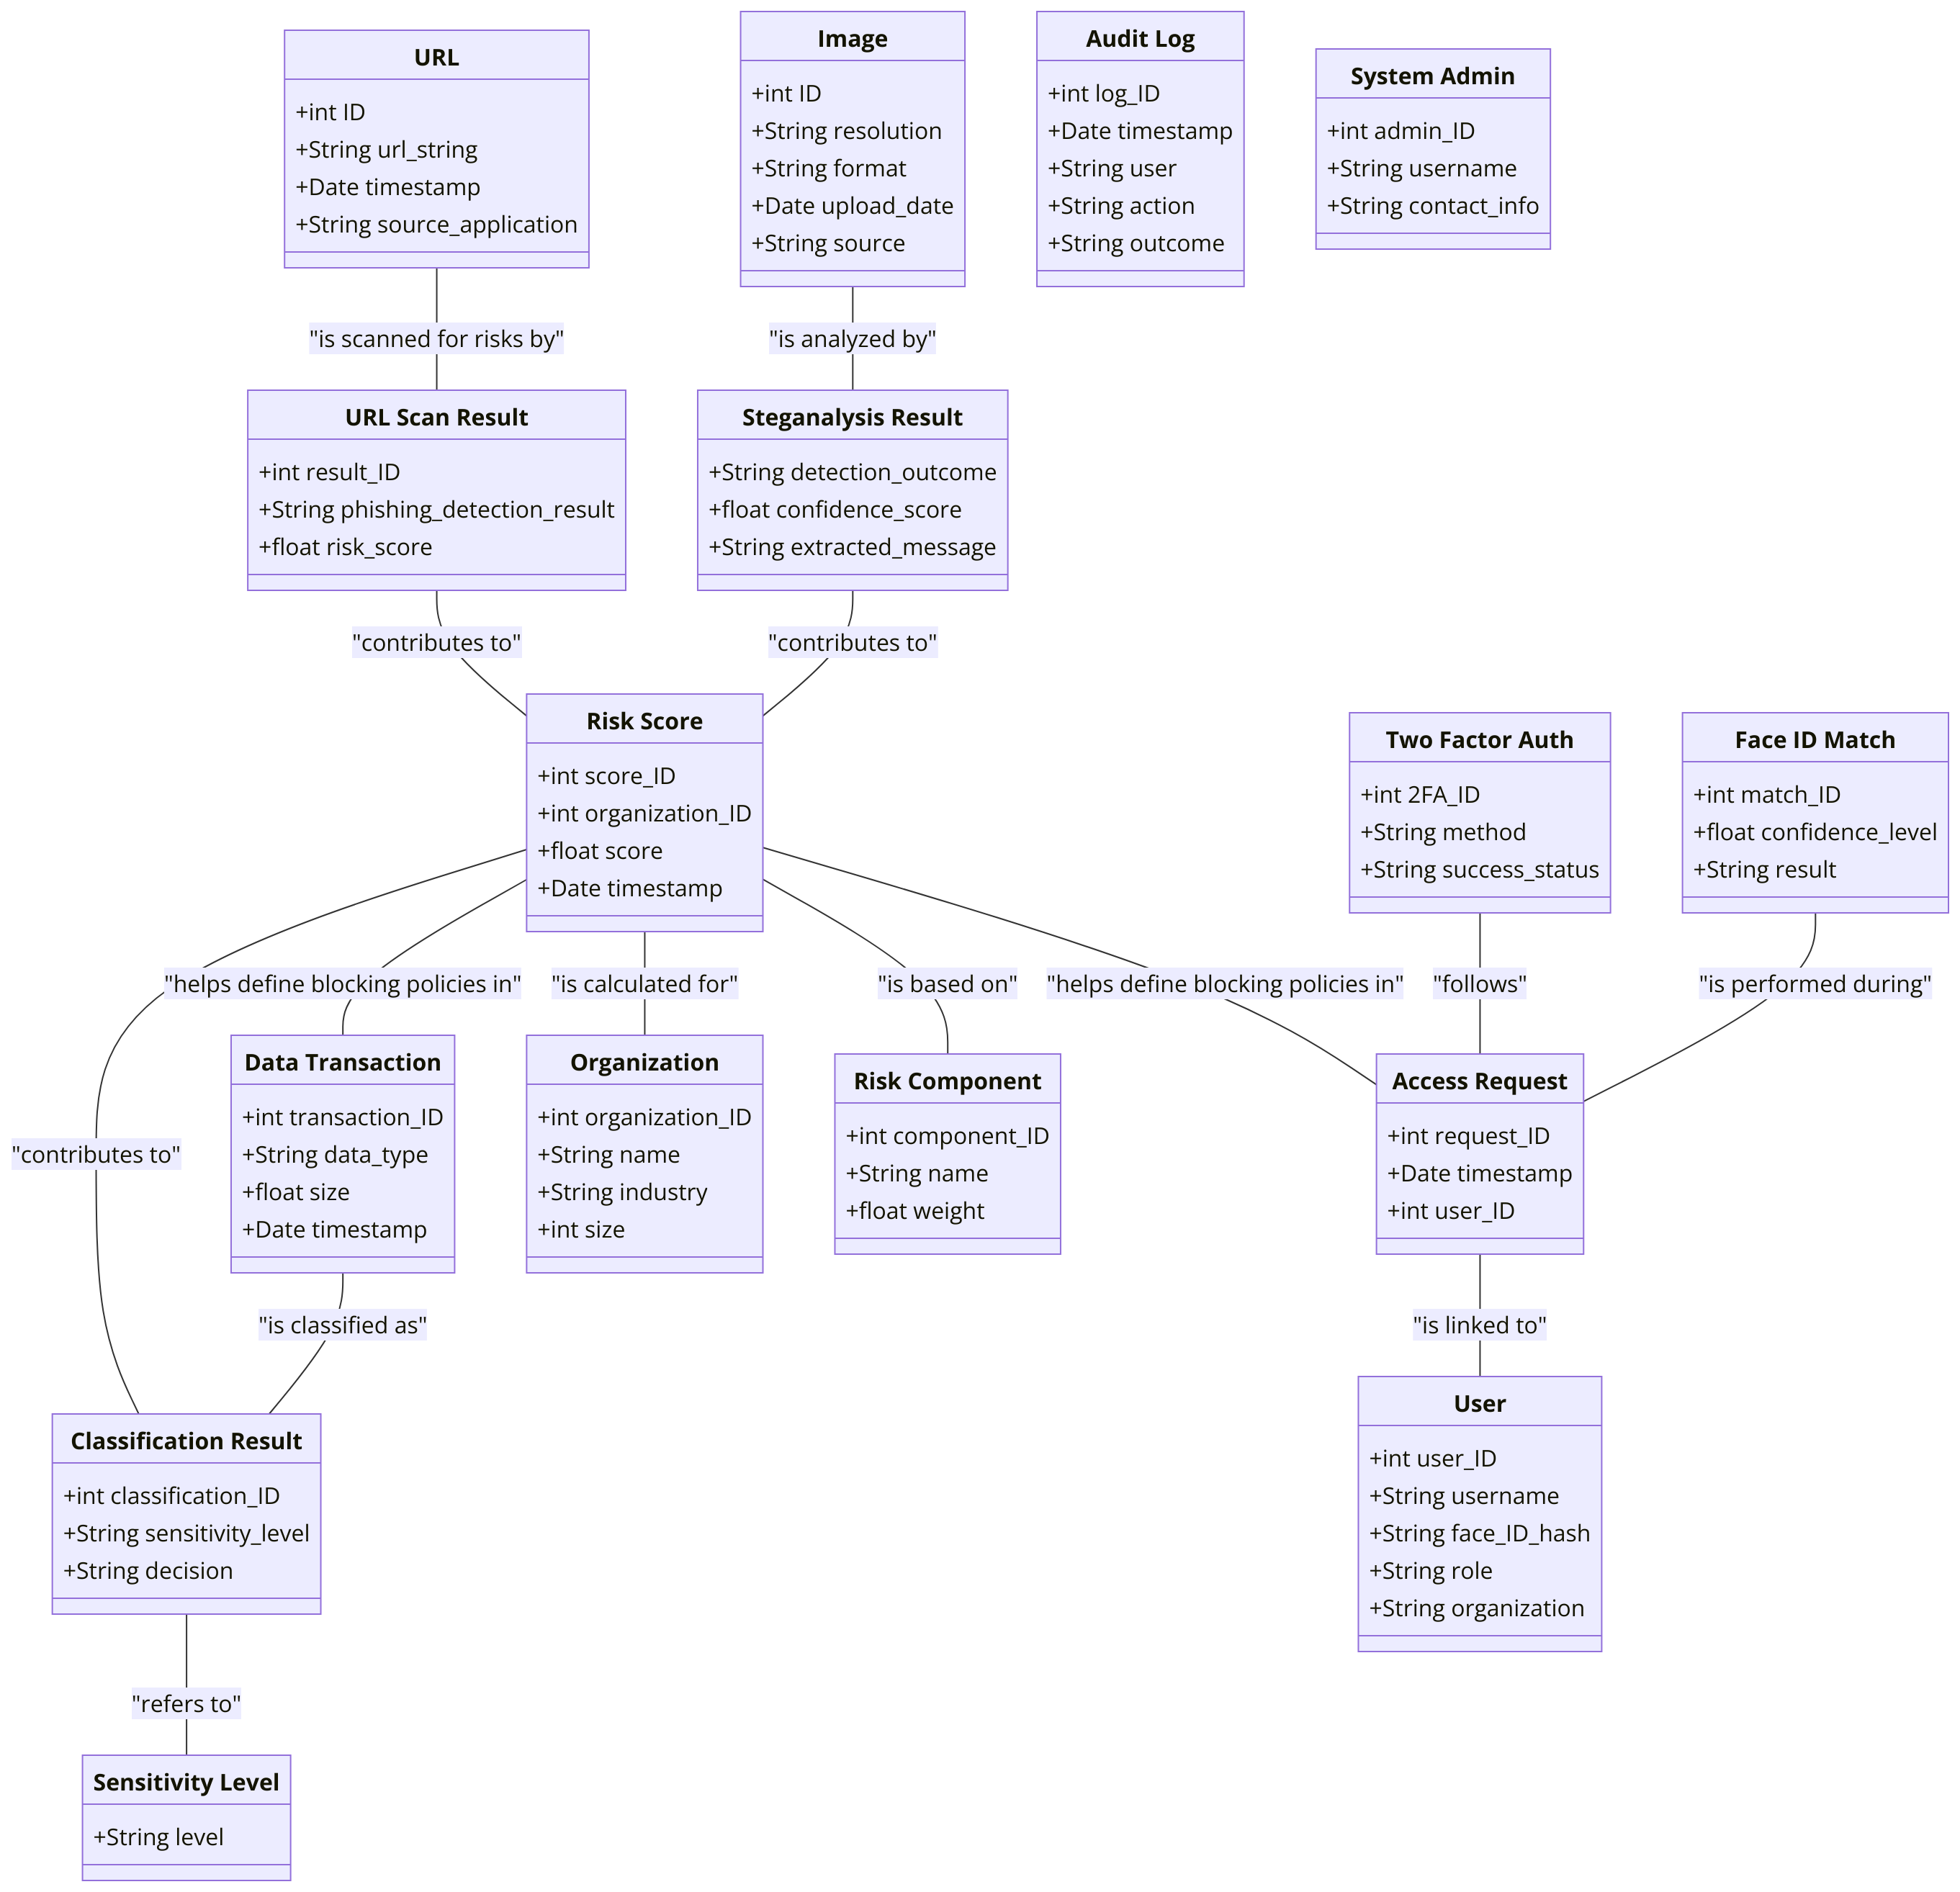
Figure 2: ER diagram
Appendix C: Issues List
• Dataset Availability:
- Issue: Finalization of datasets for training machine learning models for risk scoring and phishing detection.
- Status: Pending review of publicly available and proprietary datasets.
• Algorithm Selection:
- Issue: Final choice of machine learning algorithms for risk scoring and phishing URL detection.
- Status: TBD based on initial experiments.
• Performance Optimization:
- Issue: Optimization of homomorphic encryption computations to reduce latency.
- Status: Under evaluation for feasible trade-offs between performance and security.
• Third-Party Integration:
- Issue: Ensuring compatibility with existing SIEM systems and enterprise browsers.
- Status: Discussions with key stakeholders in progress.
• False Positives/Negatives:
- Issue: Acceptable thresholds for false positives and negatives in phishing and steganographic detection.
- Status: To be determined during testing.

